**Pseudo-code:**

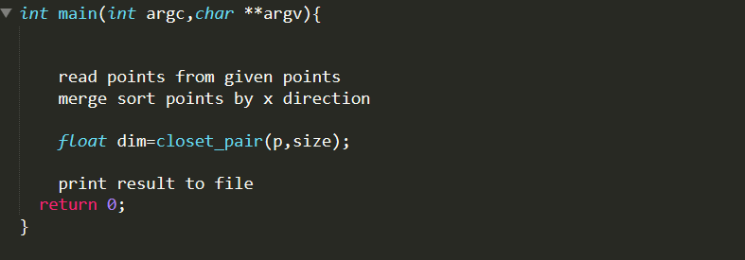

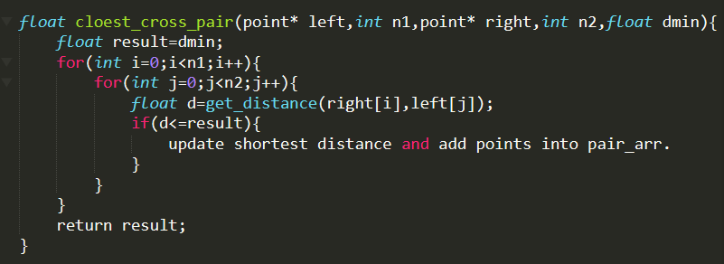

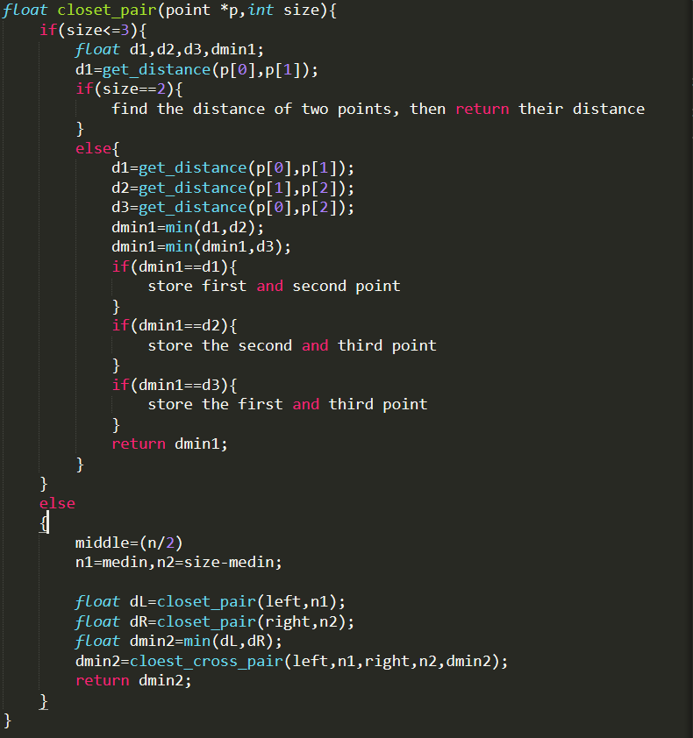

**Analysis:**

closet_pair

If(size<=3)

Find shortest distance of base case points (2 or 3 points).

Else

m = (n/2)

n1=m, n2=size-m

dl = closet_pair (left, n1)

dr = closet_pair (right, n2)

dmin2 = min (dl, dr)

dmin2 = cloest_cross_pair(left, n1, right, n2, dmin2)

return dmin2

cloest_cross_pair

for i in n1

for j in n2

get distance of right[ i ] and left[ j ]

compare to the old distance

if smaller

upgrade pair

end if

end for

end for

The divide and conquer algorithm was deployed at function closet_pair, whose base case only have sub array contained 2 or 3 points to compare their distance. After this in sub array comparation the left array and right array is going to get a cross compare which implemented at function cloest_cross_pair. It has a for loop nested in another for loop, so the time complicity would be O(n^2).

For each base case it has inner sub-array comparation which has O(1) time complexity and cross pair comparation with O(n^2), totally it has O(n^2) for each base case. For the whole recursive it divide array by two parts and call recursive twice, so T(n) = 2 T(n/2) + cn^2. Applying the master theory we get a = 2, b = 2, d = 2. a/(b^d) = 0.5 > 1, so T(n) =Θ(n^d) =Θ(n^2). So the overall time complexity would be T(n) = Θ(n^2).

|  |  |  |  |  |
| --- | --- | --- | --- | --- |
|  | 10^2 | 10^3 | 10^4 | 10^5 |
| 1 | 363 (Micro) | 29926(Micro) | 3 seconds | 194seconds |
| 2 | 305 | 23228 | 2 | 195 |
| 3 | 331 | 37339 | 2 | 196 |
| 4 | 444 | 36992 | 2 | 199 |
| 5 | 209 | 37666 | 2 | 196 |
| 6 | 210 | 40010 | 3 | 201 |
| 7 | 267 | 19360 | 3 | 197 |
| 8 | 222 | 19555 | 2 | 193 |
| 9 | 282 | 19678 | 2 | 193 |
| 10 | 406 | 19619 | 2 | 192 |
| AVG | 0.0003039s | 0.0283373s | 2.3s | 195.6s |

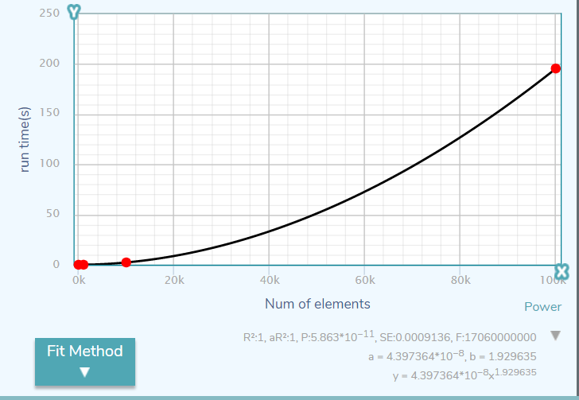

The curve fit on the plot which made by average points shown that time complexity is O(n^2)